- Battery label
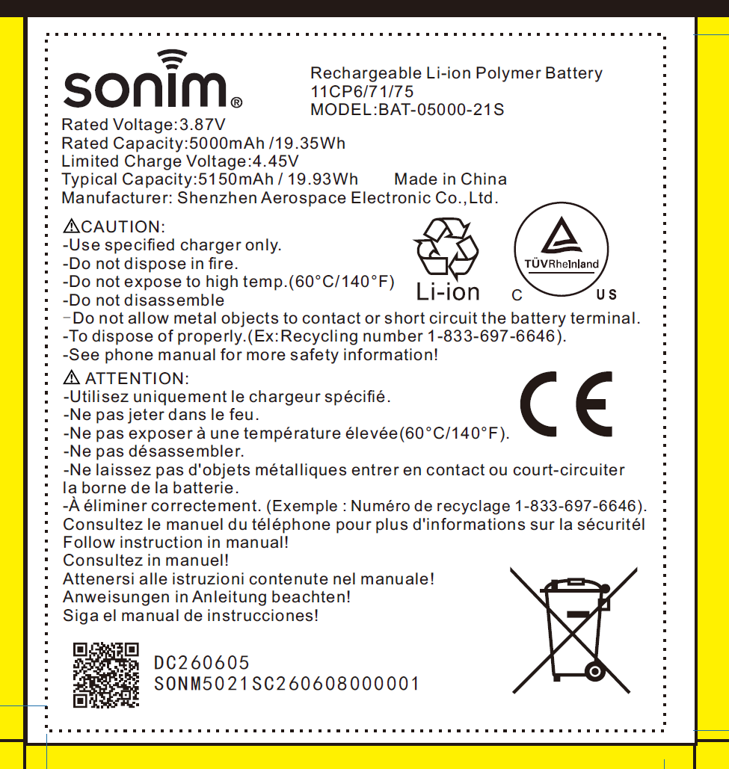

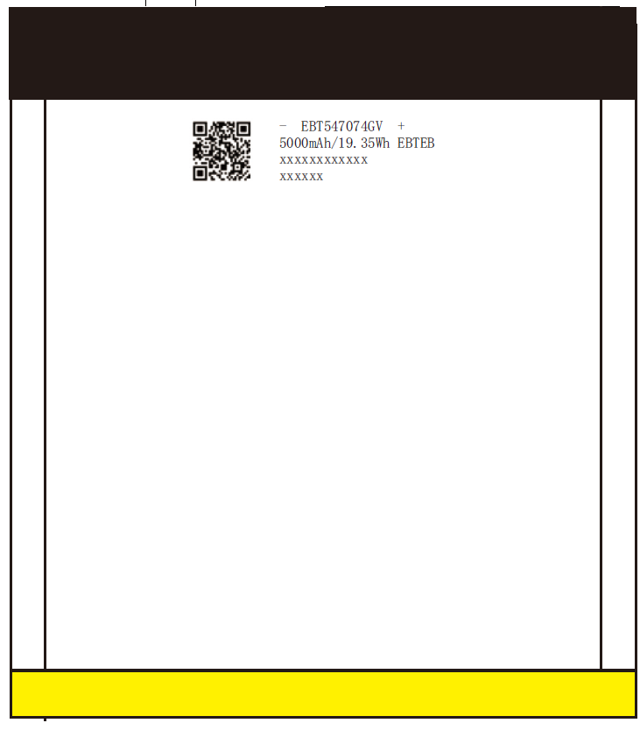
Manufacturer: Shenzhen Aerospace Electronic Co., Ltd
Address: Room 201 of 2/F, 3/F, No. 42, Langkou Industrial Zone, Langkou Community, Dalang Sub-district, Longhua District, Shenzhen City, Guangdong, China.
Website: www.sonimtech.com
E-mail: certification.ta@nexamobility.com
Weight: 66g

Use water-based fire extinguishers
Hazardous substances: none
Critical raw materials present in the battery in a concentration of more than0.1% weight by weight: LiCoO2, Polyvinylidene fluoride, Graphite powder, Electrolyte, Polyethylene,copper foil, Nickel, Aluminum foil, Stryene butadiene rubber, Carboxymethyl cellulose

- EU DOC
EU DECLARATION OF CONFORMITY

No* xxxxxxxxx * (identification number of the declaration)
- Battery model: BAT-05000-21S
- Manufacturer name: Shenzhen Aerospace Electronic Co., Ltd
Manufacturer address: Room 201 of 2/F, 3/F, No. 42, Langkou Industrial Zone, Langkou Community, Dalang Sub-district, Longhua District, Shenzhen City, Guangdong, China.
- This declaration of conformity is issued under the sole responsibility of the manufacturer.
- Product: Rechargeable Li-ion Polymer Battery
Category: Portable batteries
Rated Capacity: 5000mAh/19.35Wh
Nominal Voltage: 3.87V
Batch or serial number: XXXXXXXX
The manufacture date and battery SN can be traceable.

Stick a physical battery photo here

- The object of the declaration described in point 4 is in conformity with the relevant Union harmonisation legislation REGULATION (EU) 2023/1542.
- References standard used: IEC 62133-2:2017/AMD1:2021
- The notify body: N/A
- Conformity assessment procedures: Module A-Internal production control

Signed for and on behalf of:

Place and date of issue:

Name, function, signature

- INFORMATION ON RECYCLING, PREVENTION AND MANAGEMENT OF WASTE BATTERIES
Regulation (EU) 2023/1542 concerning batteries and waste batteries
End-users play a key role in waste prevention by making conscious purchasing decisions, reusing products, maximizing product lifespan, and appropriately sorting waste. Your daily actions help reduce the amount of waste generated and support a more sustainable and circular economy.

Best practices for optimizing battery life
There are different ways to optimize both the battery life and battery lifespan of your device. “Battery life” refers to the amount of time your device operates before it needs to be recharged. “Battery lifespan” is the amount of time your battery lasts before it needs to be replaced. Maximize both and you’ll get the most out of your device.
Tips for smartphones and tablets
Update to the latest software.
Always make sure your device is using the latest version of Android.
• To see if you need an update, go to Settings > System > System Update.
• If an update is available, you can connect your device to a power source and update wirelessly.
There are two simple ways you can preserve battery life, no matter how you use your device: adjust your screen brightness and use WiFi.
- Dim the screen or turn on Adaptive brightness to extend battery life.
• To dim, open Brightness level and drag the Brightness slider to the bottom.
• Adaptive brightness adjusts your screen to lighting conditions automatically. To activate it, go to Settings > Display. Tap Adaptive brightness, then turn on Adaptive brightness.

- When you use your device to access data, a WiFi connection uses less power than a mobile network — so keep WiFi on at all times. To turn on WiFi, go to Settings > Network & internet > Internet >Wi-Fi to access a WiFi network.
Enable Battery Saver Mode.
Battery Saver Mode temporarily reduces background activity on devices to extend battery life when the battery level gets low. Your device lets you know when your battery level goes down to 20%, and again at 10%, and prompts you turn on Battery Saver Mode with one tap. Or you can enable it by going to Settings > Battery > Battery saver.
When Battery Saver Mode is active, the battery icon in the status bar turns color. Battery Saver Mode automatically turns off when the device is charged to 90% or higher.

How to recycle electronic and battery waste
You can recycle any Sonim device or comparable devices from other manufacturers, as well as batteries, lightbulbs, and small electronics, with your local authorities, without having to purchase a new product. Recycling solutions vary from country to country. All waste must be properly classified, packaged, and labeled in accordance with all relevant laws and regulations. Independent recyclers can request instructions for removing batteries and other components that require special handling by reaching out to our email globalsupport@sonimtech.com.

How to safely handle waste batteries
Handling batteries safely, in particular lithium-ion batteries, is crucial to prevent accidents and ensure their longevity. Here are some essential tips on how to do it: For products with batteries that are not designed to be replaceable by end users, repairs should be performed by trained technicians. Unauthorized handling can lead to damage, overheating, fire, or injury. Proper disposal: Batteries may contain substances that can be harmful to the environment, and human health. Batteries should be recycled or disposed of separately from household waste and according to local environmental laws and guidelines. Protect from physical damage: Avoid puncturing, crushing, or exposing batteries to excessive heat or direct sunlight, as these actions can cause the battery to malfunction or become hazardous. Use appropriate accessories: To ensure safe charging and optimal battery performance, use power adapters that are compliant with applicable country regulations and international and regional safety standards.

The impact of hazardous substances, present in batteries, on the environment and human health
Electronic and battery waste may contain hazardous substances that must be disposed of carefully to prevent harm to natural habitats, wildlife, and human health. Many of the electronics and batteries we throw away can be recycled, which helps preserve natural resources and reduces the environmental and health risks associated with disposing of e-waste in landfills.

Your role in separating electronic and battery waste
Electronic and battery waste must be collected and recycled separately from household waste. This is part of the objectives of the EU Waste Electrical and Electronic Equipment Directive and the EU Battery and Battery Waste Regulation.

